# Update Npm Module

If there is a new minor or patch release and we type npm update, the installed version is updated, and the package-lock.json file diligently filled with the new version.

Since npm version 5.0.0, npm update will update the package.json with the updated version. Use npm update --no-save to not update package.json.

We run **npm outdated** to check the new release of the npm package.

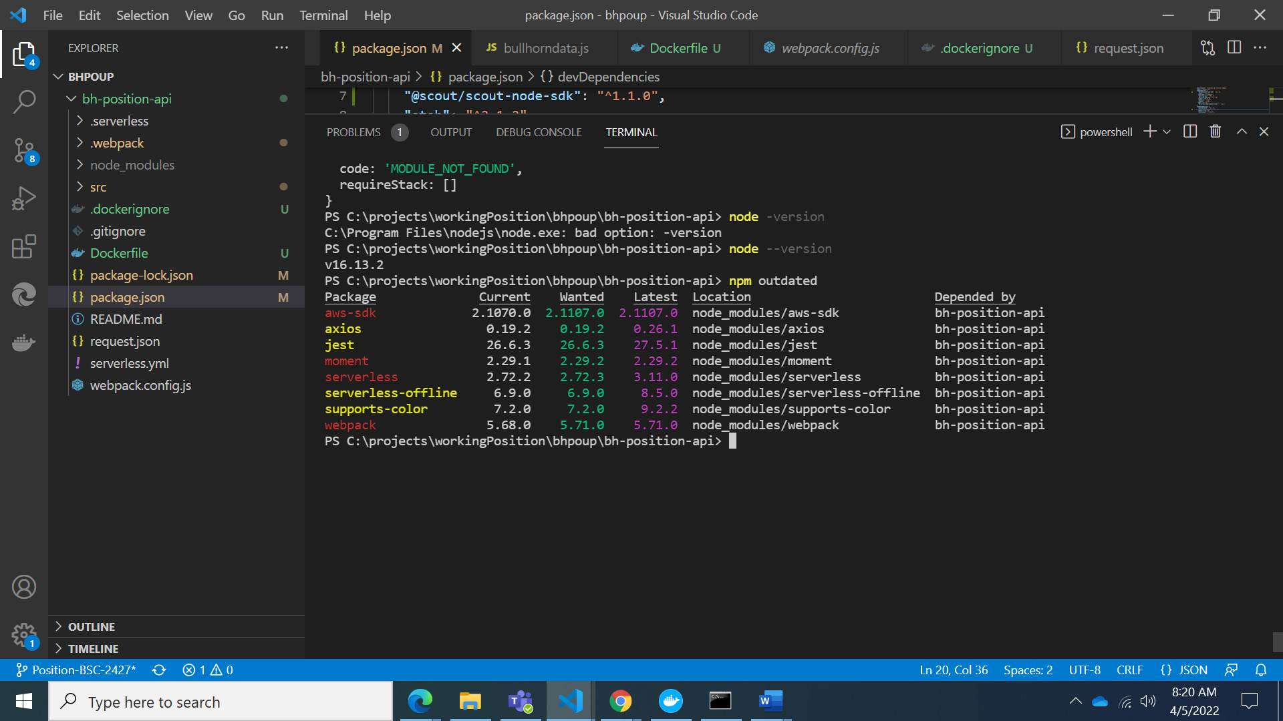

Some of those updates are major releases. Running npm update won't update the version of those. Major releases are never updated in this way because they (by definition) introduce breaking changes, and npm wants to save us trouble.

To update all packages to a new major version, install the npm-check-updates package globally:

**npm install -g npm-check-updates**

then we can run:

**ncu -u**

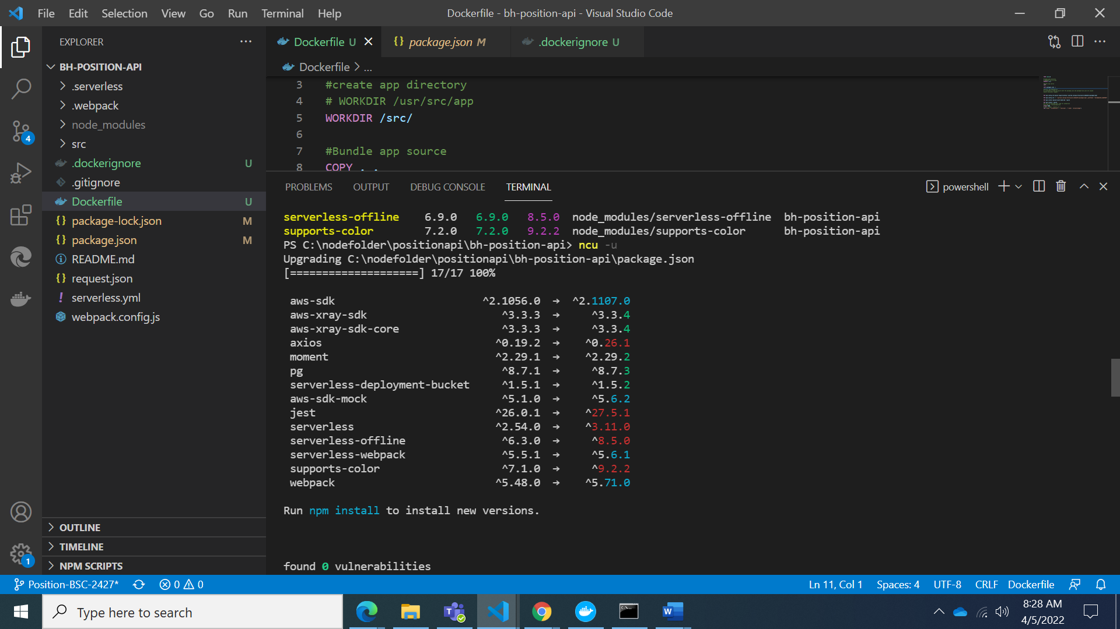

this will upgrade all the version hints in the package.json file, to dependencies and devDependencies, so npm can install the new major version.

We can run: **npm install**